**Star Wars – The Power (BI) Awakens**

for Power BI and Star Wars fans.

Inspired by the movie and by the Star war lover and Power BI expert Gil Raviv: <https://datachant.com/2018/07/28/watch-my-sessions-at-microsoft-business-applications-summit/>

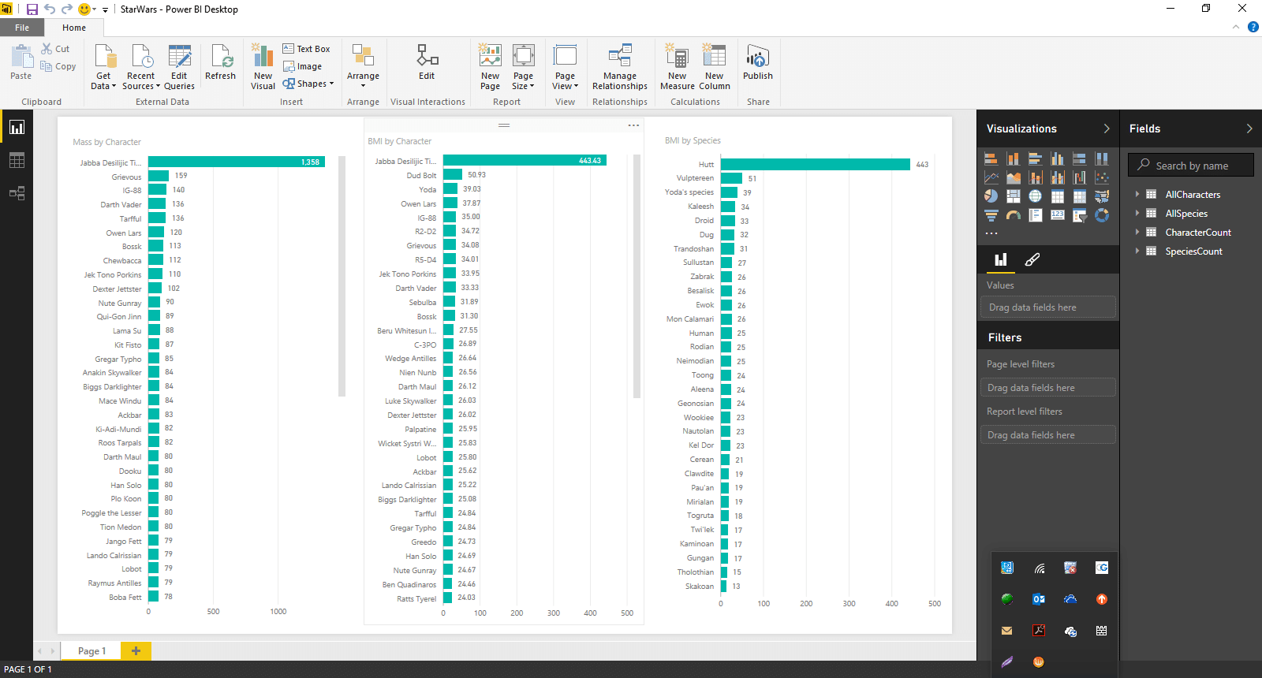

The report uses a web service, [SWAPI](https://swapi.dev/)– The Star Wars API to import all the characters from Star Wars, it then appends multiple JSON pages (thru query functions), calculates their BMI, and builds relationship between characters and species to get further insights by species.

Looking forward to seeing cool data visualizations on Power BI with this data.

-Getting the “people” into Power BI importing data from web starting from page 1: <https://swapi.dev/api/people/?page=1>

-renaming the query “SW_People_page1”, transforming the list into a table and expanding

-selecting only the columns to keep and replacing null/n/a values

From “source” rc on the count of people to get a “new query” renamed “PeopleCount”

-to import a total of 9 pages, we created a blank query renamed “people” and generated a dynamic list = List.Numbers(1, PeopleCount/10) that we then transformed into a table; change the values type to “text”

-we created a New Parameter “PageNmb”, type text, value 1

-back to the first query “SW_People_page1”, source, we cancelled the value “1” and concatenated (&) the “PageNmb” parameter

-transformed the query “SW_People_page1” into a function named “GetPeople” to get the other 9 pages

-in the “people” query we invoked our custom function “GetPeople” and expanded the new column

-removed characters from the column “species’

-replaced “unknown” with 0 in “height” and “mass” columns; changed column types

-transformed the height values in meter by dividing them by 100

-we create a custom column for BMI: =[mass in Kg]/Number.Power([height in meters],2), changed the column type to decimal

-used the same method to get “Species” (webContent https://swapi.dev/api/species?page=" & PageNumber))

-imported the table BMI from Wikipedia: <https://en.wikipedia.org/wiki/Body_mass_index> , kept only necessary columns with reference to ranges of different categories of BM

-loaded data for the query “people” into the report

-added DAX column “Category” to people based on BMI classification: Category = SWITCH(TRUE(), people[BMI]<=15, "Very severely underweight", people[BMI]<16, "Severely underweight", people[BMI]<18.5, "Underweight", people[BMI]<25, "Normal (healthy weight)", people[BMI]<30, "Overweight", people[BMI]<35, "Obese Class I (Moderately Obese)", people[BMI]<40, "Obese Class II (Severely Obese)", "Obese Class III (Very Severely Obese)")

-using the treemap, we have “name” on “group”, “BMI” on “values”

-we created a measure Count of People = COUNTROWS(People) to use in a visual with “species” and in another with “category”

-using the “what if factor” we got a “Droid Factor” parameter, starting at 0.1, ending at 1 with increment of 0.1 (this will allow the user flexibility to increment the BMI for the droids on a slider, since droids are made of metal, therefore heavier than other species with regular BMI)

-we wrapped the Droid factor parameter into a measure “Droid BMI” = [BMI2] * 'Droid Factor'[Droid Factor Value]

- then we created a measure “Galactic BMI” to assess the BMI of droids based on their custom “Droid BMI” and the BMI of Hutts (10% of average BMI) creating the measure: Galactic BMI = AVERAGEX (VALUES(Get_Species), SWITCH (Get_Species[name], "Droid", [Droid BMI], "Hutt", [BMI2]/10, [BMI2]))